DEEP LEARNING

Deep learning is the subfield of Machine Learning which uses Artificial Neural Network composed of multiple layers and they are trained by the Input to predict output ,extract Pattern or Features from the input. It has the ability to automatically learn feature from raw data without manual feature engineering which is contrast to Traditional

Machine Learning which requires domain d=knowledge and feature to be effective

Why Deep Learning ?

One of the main reasons why deep learning is so powerful is due to its ability to learn increasingly complex representations of the data as the network goes deeper. This allows it to model highly nonlinear relationships that may not be easily captured by traditional machine learning algorithms, and to make highly accurate predictions on complex datasets such as image, video, and speech recognition.

Neural Network representation

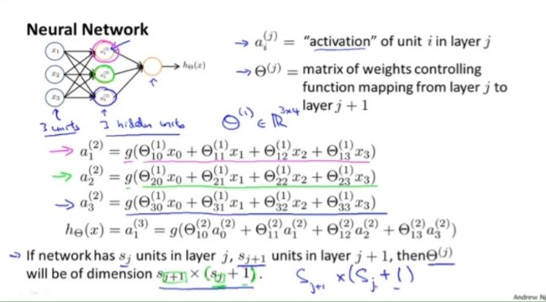

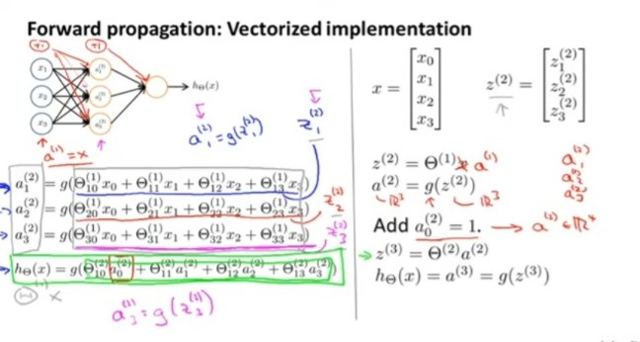

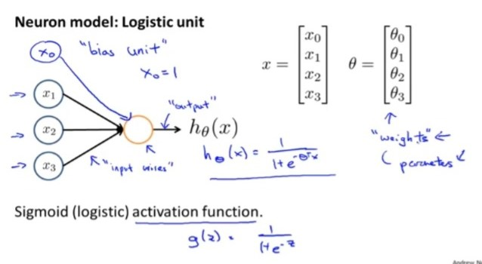

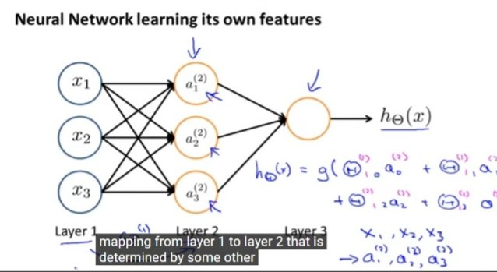

Neural Network Example and Intuition

A Simple And Gate using NN

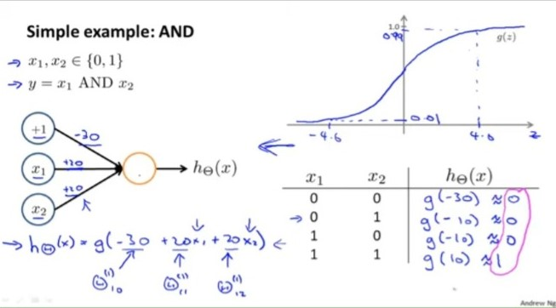Simple XNOR GATE REPRESENTATION

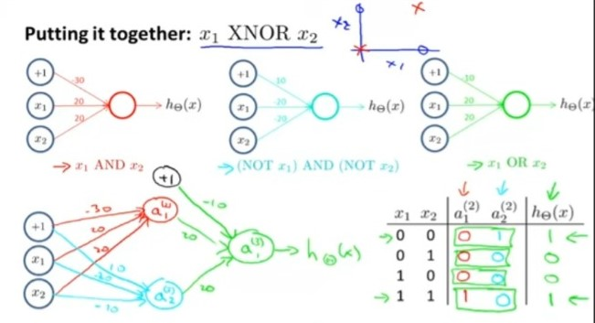

**Note : Each node in a layer is a new feature**

**Multiclass Classification**

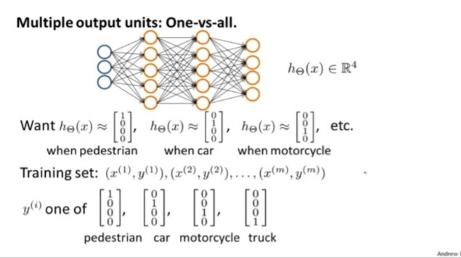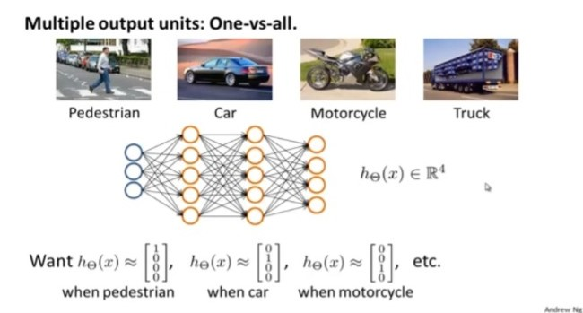

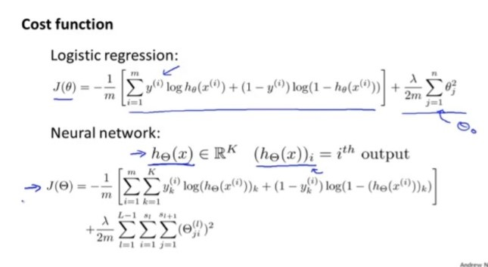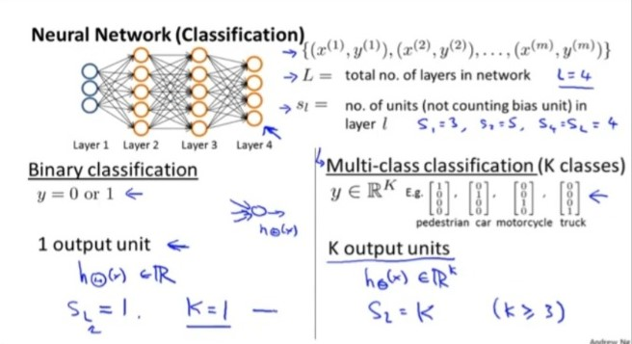

Backpropagation Algorithm

Backpropagation is an algorithm used in the field of artificial neural networks to train models through a process called supervised learning. It is a widely used technique for adjusting the weights of a neural network to minimize the difference between the predicted output and the actual output.

The backpropagation algorithm consists of two phases: the forward pass and the backward pass.

The backpropagation algorithm leverages the chain rule from calculus to calculate the gradients efficiently. It computes the gradients layer by layer, starting from the output layer and moving backward. This way, it determines how much each weight in the network contributes to the overall error and adjusts them accordingly to improve the model's performance.

It is important to note that backpropagation requires the neural network to have differentiable activation functions and differentiable loss functions. The algorithm has been instrumental in training deep neural networks, enabling them to learn complex representations and solve a wide range of problems in areas such as image recognition, natural language processing, and more.

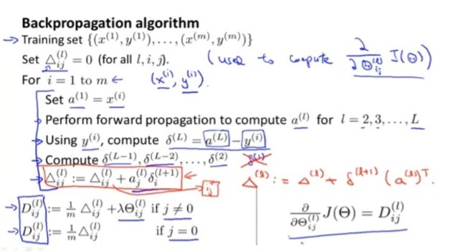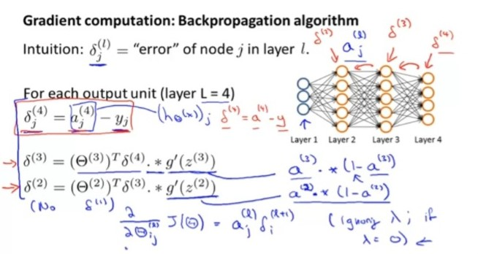

**Gradient Checking**

It is used to check if our gradient descent for error estimation works correctly

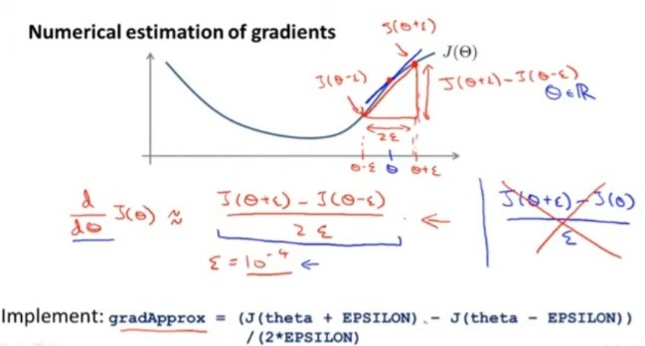

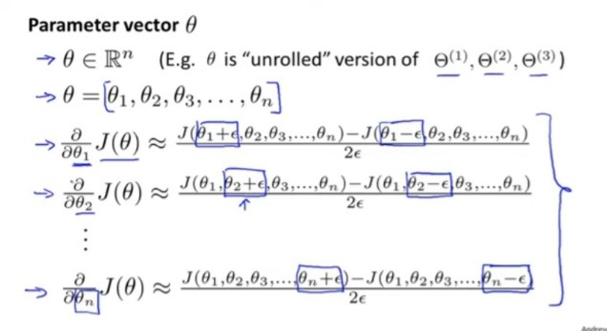

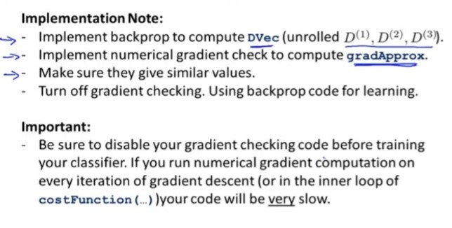

Theta Initialization

For Gradient Descent and advanced Optimization we need to have initial value for theta

Zero Initialization

In case all the theta values are initialized to zero, It leads to all the nodes in a layers have the same feature it causes redundancy and our model accuracy is low

Random Initialization

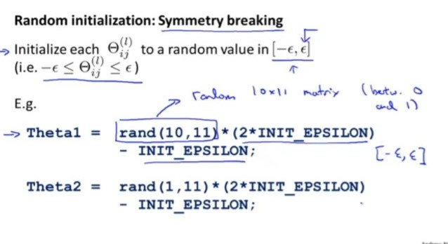

Learning Procedure

